**Histogram-Based Correlative Face Recognition Measure: A Comparison with Structural Similarity**

**Ali Nadhim Razzaq1; Zahir M. Hussain2,3; Hind Rustum Mohammed2**

1 MSc Candidate; Faculty of Computer Science & Math, University of Kufa, Iraq

2 Faculty of Computer Science & Math, University of Kufa, Iraq

3 Professor (Adjunct), School of Engineering, ECU, Australia

**Abstract**

This work presents a new holistic measure for face recognition. The measure is based on the correlation between the reference image histogram and the histograms of the faces in a database. Performance is measured using a confidence criterion based on the distance between the recognized person and the next possible ambiguity. Simulation results showed that the proposed measure exceeds the well-known Structural Similarity (SSIM) measure by far.

**Keywords:** Histogram; Correlation Coefficient; Structural Similarity (SSIM); face recognition; Image Processing

**1.Introduction**

Face is a complex, varied, high-dimensional pattern. Although people recognize familiar faces is easy, the machine is how to accurately identify the face is still a difficult task. However, due recognition in the authentication, security systems, and it has been obtained widely range of applications. This problem attracted many researchers, which is an important area of research in computer vision and pattern recognition [1].

face recognition methods are composed of a feature extractor like Principal Component Analysis (PCA), Wavelet decomposer to reduce the size of input and a classifier like Neural Networks, Support Vector Machines, and Nearest Distance Classifiers to find the features which are most likely to be found. In the field of face recognition, the accuracy and robustness of the algorithm largely depend on the facial feature description [2]. In general, the facial features include global and local features. Global features mainly describe the whole properties of the face, such as color, shape, used for general matching; local features, used for confirming accuracy, mainly describe the details on human face, such as scars, dimples [2].

Face recognition in the visible spectrum is a well-known field of research with many years of study using low-cost cameras. Many publications are available, containing smart and sophisticated algorithms. This field has seen steady growth due to its security applications, as well as other types of applications, such as access permission and even identity control. However, one of the main problems that researchers must overcome is the diminished recognition ability of algorithms as a result of variations in the intensity of illumination in the image[3].

There are basically three approaches for face recognition [4]:

**A. Feature base approach**

In feature based approach the local features like nose, eyes are

segmented and it can be used as input data in face detection to

easier the task of face recognition.

**B. Holistic approach**

In holistic approach the whole face taken as the input in the

face detection system to perform face recognition, This type is used in this paper.

**C. Hybrid Approach**

Hybrid approach is combination of feature based and holistic

approach. In this approach both local and whole face is used as the input to face detection system.

The paper is organized as follows; Section 2 deals with Structural Similarity for Face Recognition, section3 Histogram Correlative for Face Recognition, Section-4 is the conclusion of this study.

**2. Structural Similarity for Face Recognition**

The Structural Similarity (SSIM) index is a novel method for measuring the similarity between two images. The SSIM index can be viewed as a quality measure of one of the images being compared, provided the other image is regarded as of perfect quality [5].

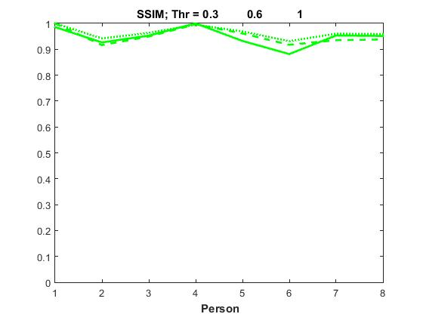

Algorithm

The SSIM index is calculated on various windows of an image. The measure between two windows x and y of common size N×N is:



with



 the average of x

the average of y

 the variance of x

 the variance of y

 the covariance of x and y

 two variables to stabilize the division with weak denominator.

We have used this method in the application of a set of thresholds to eliminate the change in illumination (0.3,0.6,1),figure2 showed Face Recognition by Structure Similarity (SSIM)

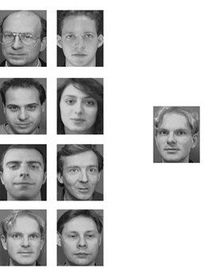

(1) (5)

(2) (6)

Image Use to match

(3) (7)

(4) (8)

**Fig.1 Sample database AT&T use to** **recognition**

**Fig.2 Structure Similarity (SSIM)**

**3. Histogram Correlative for Face Recognition**

**3.1 Histogram:**

Histogram or Frequency Histogram is a bar graph. The horizontal axis depicts the range and scale of observations involved and vertical axis shows the number of data points in various intervals that are the frequency of observations in the intervals [6]. Histograms are popular among statisticians. Though they do not show the exact values of the data points they give a very good idea about the spread of the data and shape. The histogram is a valuable tool used to view the intensity profile of an image. It provides information about the contrast and overall intensity distribution of an image. The image histogram is simply a bar graph of the pixel intensities. The pixel intensities are plotted along the x-axis and the number of occurrences for each intensity represents the y-axis.

The histogram of a digital image with gray levels in the ranges [0, L-1] is a discrete function

h(rk) = nk،

Where rk is the k-th gray level and nk is the number of pixels in the image having gray level rk. It is common practice to normalize a histogram by dividing each of its values by the total number of pixels in the image, denoted by n. Thus, a normalized histogram is given by p(rk) = nk/n, for k= 0, 1,....., L-1. Loosely speaking, p(rk) gives an estimate of the probability of occurrence of gray level rk. Note that the sum of all components of a normalized histogram is equal to 1. face from AT&T database image is represented in figure(3). Histogram of the face is shown in figure(4).

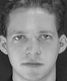

**Fig.3 Face AT&T**

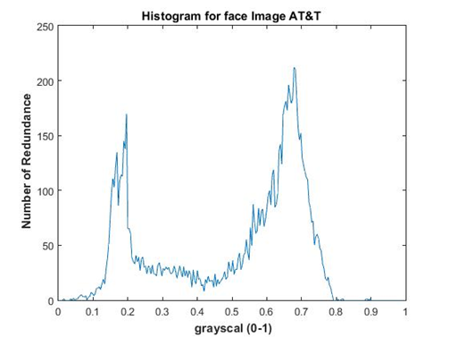

**Fig.4 Histogram for face AT&T**

**3.2** **Correlation** **Coefficient:**

The correlation coefficient, sometimes also called the cross-correlation coefficient, common usage of the word correlation refers to a relationship between two or more objects (ideas, variables...). In statistics, the word correlation refers to the relationship between two variables [7]. It computes the correlation coefficient between A and B, where A and B are matrices or vectors of the same size.

Class Support A and B can be numeric or logical. The return value r is a scalar double.



Where $\overline{A}$ = mean2(A)، and $\overline{B}$ = mean2(B).

We have used this method in the application of a set of thresholds to eliminate the change in illumination (0.3,0.6,1).

Used the same sample in Figure(1).

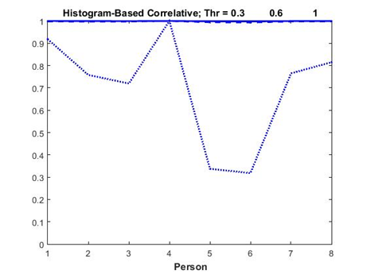

**Fig.5** **Histogram-Based Correlative**

**4. Conclusion:**

This paper presents a new technique to identify the face (called Histogram-Based Correlative), These results are compared with the structure similarity (SSIM).

And numerically simulate a system using MATLAB to use part of AT&T's[8] base, which consists of 49 facial images and contains seven articles with each subject having seven poses with various facial expressions data. The results showed that the Histogram-based correlative is better than the well-known structure similarity (SSIM) and Histogram-Based Correlative known when used in face recognition.

**References**

Yongjiao Wang, Chuan Wang, and Lei Liang,"Sparse representation theory and its application for face recognition"، International Journal on Smart Sensing and Intelligent Systems vol. 8, no. 1, march 2015.

Y. Zhu and S. Can, Sub-Image Method Based on Features Sampling and Feature Fusion for Face Recognition, Journal of Software, vol. 23, no. 12, pp.3210-3220, 2012.

Gabriel Hermosilla, Francisco Gallardo, Gonzalo Farias and Cesar San Martin," Fusion of Visible and Thermal Descriptors Using Genetic Algorithms for Face Recognition Systems", Sensors,, vol. 1, no. 15, 2015. [www.mdpi.com/journal/sensors](http://www.mdpi.com/journal/sensors)

Jigar M. Pandya, Devang Rathod, Jigna J. Jadav,” A Survey of Face Recognition approach”, International Journal of Engineering Research and Applications (IJERA) ISSN: 2248-9622 www.ijera.com Vol. 3, Issue 1, January -February 2013, pp.632- 635

Z. Wang, A. C. Bovik, H. R. Sheikh, and E. P. Simoncelli, “Image quality assessment: from error visibility to structural similarity,” IEEE Trans. Image Process., 13 (4), 2004.

Sarbjeet Singh, Meenakshi Sharma and Dr.N.SureshRao "Robust & Accurate Face Recognition using Histograms" International Conference on Emerging Trends in Computer and Image Processing (ICETCIP'2011) Bangkok Dec., 2011.

Rodgers, J. L. and Nicewander, W. A. (1988). "Thirteen ways to look at the correlation coefficient". *The American Statistician* **42**: 59–66.

AT&T Laboratories, The Database of Faces, Cambridge [online], ©2002 [accessed 10/09/2014]. Available from: <http://www.cl.cam.ac.uk/research/dtg/attarchive/facedatabase.html>

|  |  |  |  |
| --- | --- | --- | --- |
| **Image** | **Thr(0.3)** | **Thr(0.6)** | **Thr(1)** |
| **1** | **0.9741** | **0.9418** | **0.9753** |
| **2** | **0.9157** | **0.8628** | **0.9186** |
| **3** | **0.9417** | **0.8940** | **0.9397** |
| **4** | **0.9884** | **0.9383** | **0.9704** |
| **5** | **0.9213** | **0.9052** | **0.9452** |
| **6** | **0.8713** | **0.8639** | **0.9083** |
| **7** | **0.9422** | **0.8806** | **0.9366** |
| **8** | **0.9405** | **0.8833** | **0.9352** |

**Table(1). structure similarity(SSIM)**

|  |  |  |  |
| --- | --- | --- | --- |
| **Image** | **Thr(0.3)** | **Thr(0.6)** | **Thr(1)** |
| **1** | **0.9999** | **0.9968** | **0.8263** |
| **2** | **0.9996** | **0.9957** | **0.6822** |
| **3** | **0.9992** | **0.9963** | **0.6474** |
| **4** | **1.0000** | **0.9986** | **0.8998** |
| **5** | **0.9985** | **0.9931** | **0.3036** |
| **6** | **0.9978** | **0.9919** | **0.2862** |
| **7** | **0.9994** | **0.9963** | **0.6886** |
| **8** | **0.9998** | **0.9966** | **0.7335** |

**Table(2). Histogram Correlative**

**Matching using Correlation Coefficient**

**(0,1)**

**Input Image**

**Pre-processing**

**threshold (0.3,0.6,1)**

**histogram**

**for face**

**AT&T**

**database**

**Pre-processing**

**threshold (0.3,0.6,1)**

**histogram**

**for face**

**Fig.6 Steps of Face recognition**